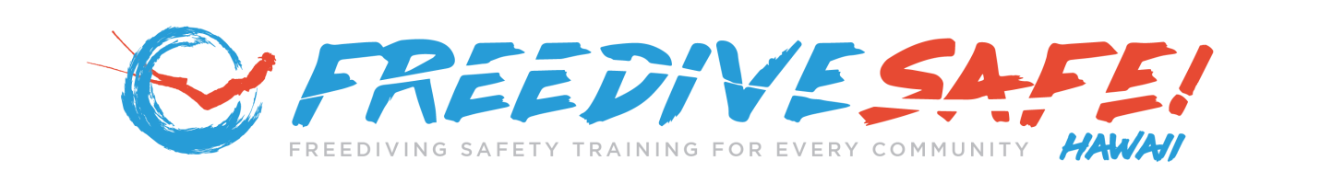

FREEDIVING SAFETY RULES FOR SPEARFISHING COMPETITIONS

Last Updated: June 2026

Purpose
These safety rules establish minimum safety requirements for participants, safety personnel, organizers, and volunteers involved in invasive species spearfishing competitions, general spearfishing competitions, and related competitive spearfishing activities. The objective is to promote participant safety through preparation, buddy awareness, emergency readiness, responsible freediving practices, and the consistent application of recognized safety principles.

1. NEVER DIVE ALONE
All participants shall utilize a buddy system.
- Divers shall maintain awareness of their buddy's location and condition.
- Buddy teams shall remain capable of providing immediate assistance when needed.
- Solo diving is prohibited.

2. ONE UP / ONE DOWN
- One diver is actively diving.
- One diver remains at the surface monitoring the diver below.
Divers shall maintain continuous awareness and supervision of their buddy during ascent and surface recovery.

3. SURFACE SUPERVISION
Divers shall be monitored during:
- Final ascent
- Surface recovery
- Post-dive breathing and recovery period
Special attention shall be given during the first thirty (30) seconds following surfacing.

4. USE A FLOAT AND FLAG
Participants shall utilize an appropriate float and flag system.
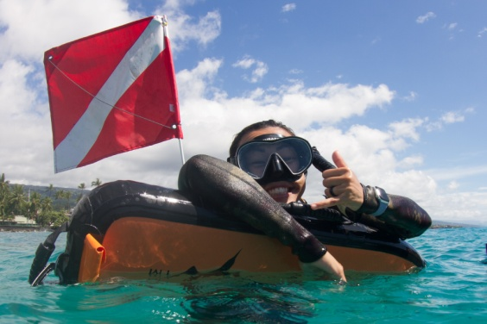
The float and flag shall:
- Improve visibility.
- Emergency floatation.
- Support diver accountability.
- Assist safety personnel in locating participants.
- Promote safe operations around vessel traffic.
Hawaiʻi Divers: Participants should be familiar with applicable state laws regarding diver's flags. In Hawaiʻi, diver's flag requirements are addressed under Hawaiʻi Administrative Rules (HAR) § 13-245-9 (Diver's Flag). When diving in Hawaiʻi waters, participants are responsible for complying with all applicable state laws and regulations.

5. ADDITIONAL SAFETY EQUIPMENT
Participants are strongly encouraged to carry simple emergency signaling devices capable of attracting attention during an emergency.

Sound Signaling Device
A whistle or other sound-producing signaling device is recommended and should be readily accessible while diving.
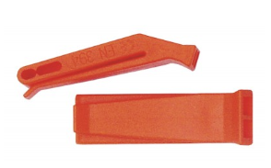
Sound signaling devices may be used to:
- Attract attention during an emergency.
- Alert nearby divers or vessels.
- Summon assistance when needed.
- Enhance communication when voice communication may be ineffective.

Visual Signaling Device
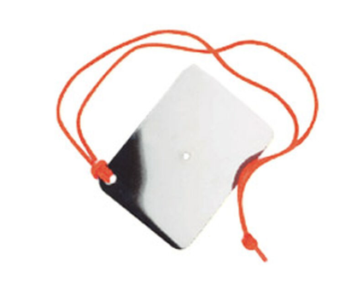
A signaling mirror or other visual distress-signaling device is recommended and should be carried when practical.
Visual signaling devices may be used to:
- Attract attention from vessels or shore personnel.
- Assist rescuers in locating divers.
- Increase visibility during emergency situations.
- Support emergency response efforts.
Participants should become familiar with the proper use of signaling devices before entering the water.

Portable GPS Emergency Communication Device
A portable GPS emergency communication device, such as a Garmin inReach® or similar satellite communication device, is recommended for offshore, remote, or isolated diving locations where cellular phone coverage may be unavailable or unreliable.
GPS communication devices may be used to:
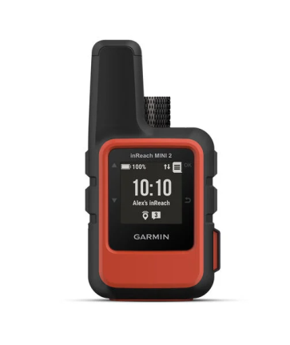
- Transmit emergency distress messages.
- Communicate with emergency contacts.
- Share location information with responders.
- Assist search and rescue personnel in locating divers.
- Enhance emergency preparedness during remote spearfishing activities.
Participants should become familiar with the operation, emergency functions, battery requirements, and communication capabilities of the device before entering the water.
While not a substitute for proper dive planning, buddy supervision, emergency procedures, or required safety equipment, a GPS emergency communication device can provide an additional layer of safety during serious emergencies.

6. SAFE WEIGHTING
Participants should utilize the minimum amount of weight necessary to dive safely within their intended depth range and environmental conditions.
As a general guideline, divers should be capable of maintaining positive buoyancy at the surface and floating comfortably with the water level approximately at collarbone height following a full inhalation.
Divers are responsible for evaluating weighting requirements based upon:
- Body composition
- Exposure protection worn
- Equipment configuration
- Water conditions
- Planned diving depth
Excessive weighting increases risk and should be avoided.

7. REMOVE THE SNORKEL BEFORE DIVING
Divers should remove the snorkel from their mouth prior to submersion.
Maintaining a snorkel in the mouth while underwater may increase risk during a hypoxic incident by potentially contributing to water aspiration.
Divers should:
- Remove the snorkel before descent.
- Maintain proper surface recovery procedures following ascent.
- Reinsert the snorkel after recovery breathing and once fully recovered at the surface.
Consistent snorkel-removal habits are an important component of responsible freediving and spearfishing safety practices.

8. BREATHE NORMALLY
Participants shall:
- Use calm, relaxed breathing before diving.
- Avoid hyperventilation.
- Follow safe breathing and recovery practices.
- Take regular 5 min intervals to sufficiently recover.

9. KNOW YOUR LIMITS
Participants shall:
- Dive within their experience and comfort level.
- Avoid unnecessary risk-taking.
- Terminate dives when conditions become unsafe.
- Discontinue participation if experiencing illness, fatigue, injury, dehydration, or impaired judgment.

10. MAINTAIN EQUIPMENT
All equipment shall be inspected prior to use.
Participants are responsible for ensuring:
- Masks function properly.
- Snorkels are serviceable.
- Fins are secure and undamaged.
- Floats and flags are properly rigged.
- Signaling devices are accessible and functional.
- Spearfishing equipment is maintained in safe working condition.

11. RESPECT CONDITIONS
Participants shall continuously evaluate:
- Weather conditions
- Visibility
- Current
- Surf
- Boat traffic
- Marine hazards
Competition activities may be modified, suspended, or terminated when conditions create unacceptable risk.

12. REPORT PROBLEMS IMMEDIATELY
Participants shall immediately report:
- Distress or injury
- Equipment failures
- Missing divers
- Unsafe conditions
- Medical concerns
Early reporting improves outcomes and enhances overall event safety.

13. FOLLOW SAFETY PERSONNEL DIRECTIONS
Participants shall comply with directions provided by:
- Event organizers
- Safety officers
- Safety divers
- Designated competition personnel
Safety decisions made by event personnel are final and are intended to protect participants and support safe competition operations.

14. UNSAFE DIVING PRACTICES
Participant safety is the highest priority during all competition activities.
Competitors who engage in unsafe diving practices may be subject to corrective action, including verbal warnings, temporary suspension from competition activities, disqualification from specific events, or removal from the competition.
Examples of unsafe diving practices may include:
- Diving without appropriate buddy supervision.
- Failure to monitor a buddy.
- Repeated violations of established safety procedures.
- Hyperventilation or other unsafe breathing practices.
- Ignoring directions from safety personnel or event officials.
- Diving beyond personal capabilities or established event limitations.
- Conduct that places the participant or others at unnecessary risk.
Competition organizers, safety officers, and designated event personnel retain the authority to suspend or remove participants from competition activities when safety concerns exist.

15. REMEMBER THE FREEDIVESAFE SAFETY PRINCIPLE

WATCH YOUR BUDDY.

PROTECT THE AIRWAY.

GET HELP.
The first person to recognize a problem is often the person closest to it.
That person is usually the buddy.

SAFETY FIRST
Competition results are never more important than participant safety.
FreediveSafe supports proactive intervention, including suspension from competition activities, whenever unsafe diving practices are observed.
Any participant, safety diver, or event official may stop a dive, request assistance, or withdraw from competition whenever safety concerns exist.

FreediveSafe!
Promoting safer freediving, spearfishing, and aquatic participation through education, awareness, and responsible buddy practices.

